**Branch 2025Q1 created on slave 1 machin**

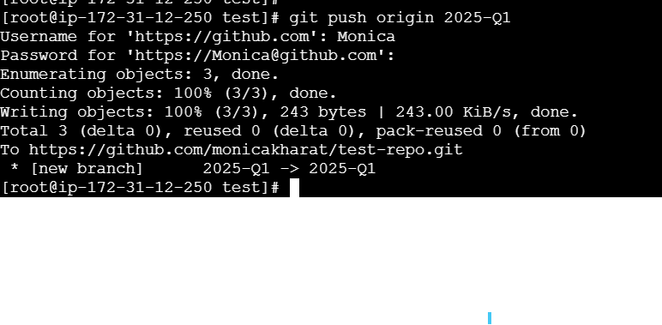

**Branch 2025Q2 created on slave 2 machin**

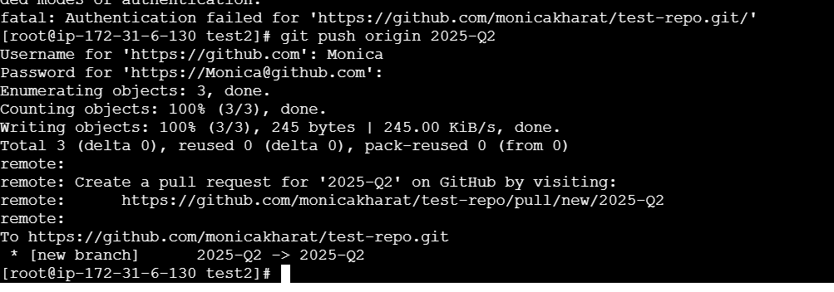

**3 Branches are created at git hub and push individual index.html file for each branch**

